'Your Big Idea' Explain your innovation

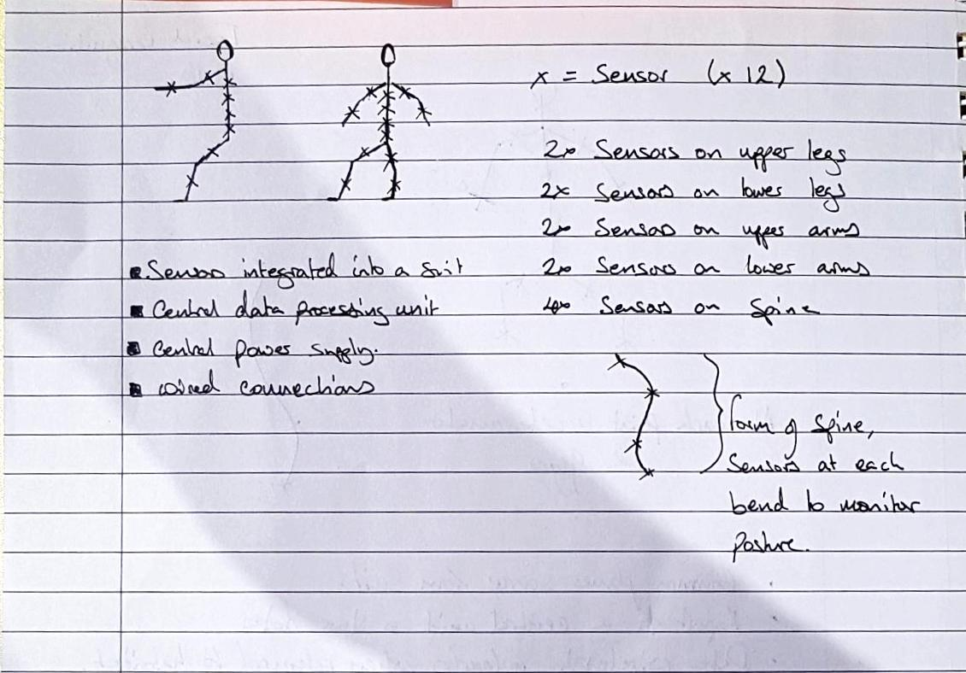

**How does it work?**

Visual Description - A skin tight suit containing 16 sensors at key points along the body, a control unit and a power supply. Sensors are positioned, 1 for each lower limb, 1 for each upper limb, and 4 along the length of the spine, see positioning of the ‘x’ marks on the stick men.

The Sensor - Each sensor will be comprised of an accelerometer and gyro, this mean that for each point on the body, orientation and directional movement can be determined (angle to reference, velocity, acceleration). Example sensor dimension (4.1mm x 4.1mm x 0.95mm, MPU-6050). [hobbiest level equpment] <https://datasheet.octopart.com/MPU-6050-InvenSense-datasheet-21631037.pdf>

Communication - Sensors will be coordinated by a central controller (by wired connections) that will manage sensor output, data storage and wireless communication to a computer system.

Power - The sensors and controllers will all run from a central power supply, this means that the weight of the system can be kept closer to the users body and means that sensor units will be less intrusive. The GT1M is lightweight (27 g), compact (38mm × 37 mm × 18 mm) [Military level equipment]

“Recognition of Military-Specific Physical Activities With Body-Fixed Sensors, Thomas Wyss , MSc ; Urs Mäder , PhD”

Presentation Statements

How Does it Work (30) -

Our Product is a full body suit containing 16 Sensors that will run from a central power supply and controller.

The suit will collect motion data on the user as they conduct their business in any environment, which can be stored locally or transmitted to an external system. On a mars mission this data can be used to identify the condition of an astronaut, if they incur an injury for example.

Such a system can be used to help prevent injury, which is of importance when you are so far from conventional medical facilities. Being able to notify an someone if they are lifting something dangerously for example. Over the course of a mission collected data can be used to analyse an individual's physical performance.

Data collected can be used to analyse

Ford Used motion tracking data to blah blah

Discuss Applications (25) -

Reveal (5) -

Enactus Business Guy - Make use of the technology in a terrestrial environment to fine tune and make money from and then move onto developing mars version and

Business Canvas model

Infrastructure -

Offering

Customers

Financing